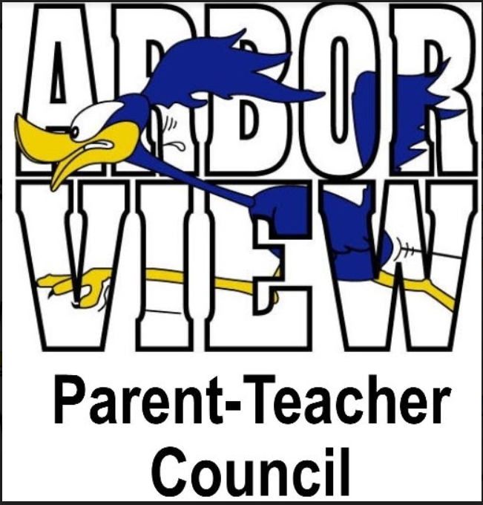

Agenda
November 9, 2021

- Call to Order
  - Meeting called to order at 7:02 p.m.
- Approval of Minutes
  - Minutes approved.
- Presentation: Superintendent Dr. Tammaru, Board Member Mr. Lerch- Update on District, Q & A session
  - Dr. Tammaru began with a thank you to staff for navigating a “year like no other” with everyone working around the clock to ensure that students have the best experience possible followed by a thank you to community/families. Dr. Tammaru meets with PTC presidents once a month and appreciates of all of support of families by the PTCs
  - Jay Lerch echoed Dr. Tammaru’s comments and thanked the staff and community
  - Reminder that the week of 11/15 is American Education Week
  - Feedback from school calendar survey – unilaterally, no one likes half days of school – bringing a waiver to the board to reduce the number of half days of school in the future
  - Board vacancy – 11 strong applicants, board will interview week of 11/30 to seat a new board member in December
  - Finance committee coming up to look at building/grounds facilities – will hear from consulting firm that specializes in broader community engagement, volunteers from all 5 schools to be involved, want to assure everyone that there is no additional discussion about raising taxes
  - Board approved a new strategic plan in July 2021 – not vastly different from last goals, centered on providing best experience for every single student, ensuring best staff, maintaining financial responsibility
  - District is offering a pediatric vaccination clinic on 11/20 for children ages 5-11 with second shots available 12/11 at Park View
  - District is offering a booster clinic on 11/13 at Glen Crest for adults
  - Citizens Advisory Council – meets with Dr. Tammaru and board members three times a year, open dialogue on strengths and opportunities
  - Lisa Loftsgaarden commented that she loves that half days are being used for community service
  - Reminder that parent/teacher conferences coming up prior to Thanksgiving
  - Update on social/emotional screener – 99% of families participated, identifies tier 2 and tier 3 students who are “internalizers” and may not act out at school
  - Question from Sarah Malcolm on social/emotional screener – how often will it be given to students?
    - Typically three times a year, but just twice this first year because the district started with the first one a little late
- President’s Report – Stephanie Furlong
  - Substitute teacher rate has been increased
  - For those on committees with upcoming events, contact Lauren at the district office to set up My School Bucks account with preferably two weeks notice
  - Book fair currently happening – raised $522.79 in just two hours, school shopping on 11/10 and family shopping 5-7 p.m. after school
- Treasurer’s Report – Stacy Moskos
  - Halloween Harvest expenses came in more than $500 under budget, income came in $500 over budget – made $2100 on the event thanks to lots of donated items (food, water, prizes)
- Principal’s Report – Mrs. Burnett
  - Parent/teacher conferences coming up 11/18, 11/22, 11/23; families can meet in person or use Google Meets
  - Report cards come out 11/18
  - Second round of MAP testing during the second week of December
  - Lots of people to thank – Halloween Harvest volunteers, Stephanie Furlong for her help with the book fair, lunch time helpers
  - Need four volunteers to help with 11/20 pediatric vaccine clinic
  - Need more lunch volunteers
  - Free dental clinic on 11/12 – fewer people signed up than usual
- Faculty Report – Mrs. Carlson & Ms. Clarey
  - Ms. Clarey – thanked the PTC for the Halloween Harvest with a special thank you for keeping the primary hallway intact for the haunted hallway; also thankful for the Directory Spot emails especially with toner shortage
  - Mrs. Carlson – thanked the PTC the book fair with special praise for its organization; mentioned Mrs. Wankel gave a lesson about Stone Soup and also read the book to all students
- Committee Report
  - Fundraising- Brad Hemesath (Chicago Wolves, Boosterthon)
    - two options: Chicago Wolves hockey game in winter of 2021, Boosterthon Fun Run in Spring 2021
    - Wolves - $20 ticket cost, $8 from each ticket back to PTC, Wolves hat for everyone who attends, with 30+ attending get a jersey to auction/raffle, option to add hot dog/soda for $6.50, group’s name on scoreboard – Sundays are Papa John’s Family Sundays
    - Boosterthon – 8 day pledge based character and fitness fundraiser, includes a Fun Run or Dance Fit celebration and character education program, less than 3 hours in full spread over 8 days, access to character video library, every student gets to participate in every aspect of the program regardless of whether they financially participate – 100% inclusive
  - Art Smart- Miya Wayman
    - ArtSmart partnering with Stone Soup food drive, based on the illustrator of the Stone Soup book, on track to hit goal of 2,000 items by the end of the month
  - WinterFest- Stacie Nelson
    - Winterfest committee well under way with planning, focusing more on entertainment vs. food, mingle and jingle with Elsa and Olaf, family photo shoot, balloon artist, elfie selfie station, on December 4th from 10:30-1:30, same date as Valley View Santa Parade – Mr. and Mrs. Claus will drive through the valley and then end at the school
  - Stone Soup – Holly Redfern
    - Over 1,000 items donated so far, space still available on 12/7 to sort items at the Food Pantry

- Liaison Report
- Scouts – Girl Scouts - Olivia Loftsgaarden; Boy Scouts - Lupe Santillanes
  - Olivia Loftsgaarden – Girl Scouts update – painted library windows for Halloween with Boy Scouts, went on wagon rides at Danada Equestrian Center
  - Kim C – Boy Scouts update – pack going on lots of hikes, popcorn season is over – thank you to everyone who purchased some, Veteran’s Day flag ceremony – will honor a few parents of AV students and will be livestreamed, pinewood derby coming up

- Old Business
- Halloween Harvest - Erin Ricci/Keri Poi
  - Reiterated that the event was a big success and gave thanks to everyone who volunteered

- New Business
  - Winter Parties- December 17
    - Communication to come from PTC on district policies regarding food served at parties
  - No December PTC meeting. See you all in 2022!

- Comments
  - Sarah Malcolm mentioned that if a communication needs to go out ASAP through Directory Spot, just let her know.

- Adjournment – meeting adjourned at 8:10 p.m.

